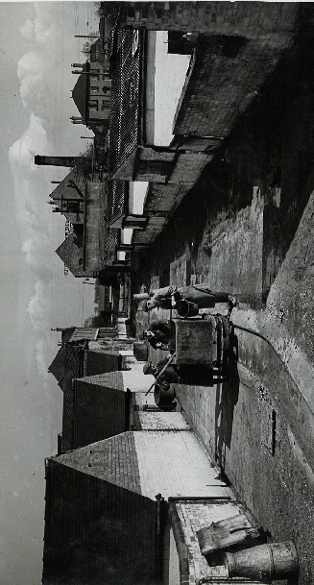
Picture provided by Midlands Co-operative Society
When you come to the Chaddesden/Spondon end of Raynesway, you will see Acorn Way in front of you and what appears to be at first glance a large detached house. You will recognise the same house in the top right hand corner of the picture above. If you turn left towards Chaddesden you will see the front of the building shown above on your left, although the top of the chimney has long gone. A few yards further on there is a detached house, you can just see the chimney in the picture above. These buildings were part of the Derby Co-operative Provident Society Farm, Dairy and Piggeries.
In 1894 the Society bought a creamery and land at Spondon and part of the land was planted with fruit trees. By the summer of 1900, the dairy workers produced 900 to 1,000 lbs of butter a week. Dairy produce was sold in the stores and used at the society’s two restaurants. Piggeries were also built to accommodate 50 pigs and a residence for the dairyman was erected (the building on the left). Milk was bought from local farmers, converted to butter and the separated milk sold to members or given to the pigs. (Holyoake and Scotton 1900)
In 1908 the Society purchased a farm of 41 acres situated on Nottingham Road opposite the Creamery for £3,600. Interestingly at the time it was seen as an excellent investment, as the land might be required for building purposes. It was used at first for horses requiring rest from working in the town streets, as well as raising cattle and fowls. In 1909 a further 11 adjoining acres were purchased. (Unsworth 1927). The Derby Monthly Record of November 1909 (Derby Co-operative’s Magazine), reports that the very large farmhouse house fronting Nottingham Road had been divided into two for the Society’s men employed on the farm. The piggeries increased to allow 200 pigs to be kept and there were plans to extend these to allow 400 pigs to be kept at one time. The trees planted earlier yielded 34cwt apples in 1909 and the creamery dealt with 1,000 gallons of milk per week and daily deliveries were made to up to 5,000 members.
The creamery and piggeries were in operation until the 1970s, although by then production had changed to cheese making. The picture above shows the daily feeding of the pigs with the remains from the cheese production, supplemented by leftovers from the Co-operative shops and restaurants, together with bought in feed. Many people still remember the trolley buses that came along Nottingham Road with destination boards showing the Creamery, which was the end of the line.
Part of the farm land was sold to build the replacement school for the old Spondon House School in the 1960s, this has since been demolished following a fire. The Creamery and Piggeries are now home to a number of businesses.
References
Holyoake. J.H. and Scotton A. 1900. The Jubilee History of Derby Co-operative Society Ltd 1850-1900. Manchester: Co-operative Printing Society
Unsworth W.L. 1927. Seventy-five Years’ Co-operation 1850-1925. Manchester: Co-operative Wholesale Society

